**Assignment 1**

1. What is JDK? JRE? JVM?

JDK(Java Development Kit) is the tool necessary to compile, document, and package java programs.

JRE is a runtime environment that provides all class libraries and other files that a java program use at runtime.

JVM is an abstract machine. It is a specification that provides runtime environments in which java bytecode can be executed.

1. What is java compiler?

Java compiler compiles(translates) java code into Java class files containing platform-neutral Java bytecode.

1. Why is java platform independent?

Because java code will be compiled into Java bytecode with java compiler. The Java bytecode cannot be understood by any specific platform. The Java bytecode will be executed by JVM which is dependent to platforms. Therefore, Java itself is platform independent, but JVM is required to run java programs.

1. What is IDE? Why is it important for developers?

IDE is a software suite that consolidates basic tools required to write and test software. An IDE brings tools like text editors, code libraries, compilers and test platforms together as a single framework, application or service. IDE can simplify software development and identify and minimize coding mistakes and typos.

1. Is java case sensitive?

Java is case sensitive. Different naming indicates different objects or methods.

1. What do the following key words do?  
   static, final, public, private, void, null, package, Class, new

Static: Marks that the member(method or variable) belongs to the class itself, rather than to any instance of the class.

Final: Final keywords marks that the member cannot be changed. A final class cannot be extended, a final method cannot be overridden, a final variable is a constant.

Public: public represents the scope of the member. A public member can be accessible by any other class.

Private: A private member can only be accessible within the declared class.

Void: A keyword in signature marks that the method does not return any value.

Null: null is not object; it is a special value that can be assigned to any reference type to represent a literal value.

Package: package keyword creates a package namespace. Classes in the same package have access to each other’s package-private and protected members.

Class: class keyword declares a new Java class. Class is a collection of related variables and methods. It is the basic building block of OOP.

New: new keyword initiates a new object, an instance of a class.

1. What is primitive type and reference type?

Primitive data type contains pure, simple values of a kind.

Reference type contains the address where an object’s variable and methods are stored.

1. Is parameter passed by value or reference?

Passed by value.

1. What is the output: System.out.println(1 > 0 ? “A”:”B”); A
2. How to define constants in java?

Using the final keyword on variables

1. What is String? Is it primitive type?

String is an object, not a reference type. It is basically an object containing an array of chars.

1. How to check if a String is representing a number?

Depending on the expected number format, we can use Java built-in methods like Integer.parseInt, Double.parseDouble, Float.parseFloat, Long.parseLong.

1. Write a program to implement the following activity diagram:

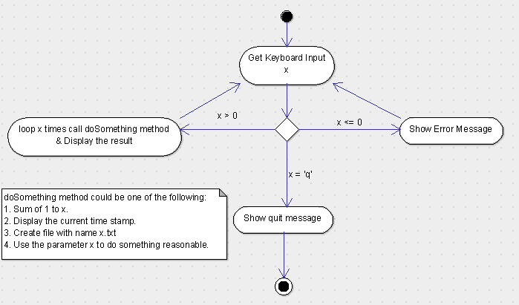

1. Write a program to merge two array of int.
2. Write a program to find the second largest number inside an array of int.